How RISC sets influence ARM Processors

Sam Yan Vincent
Computer Science department, Wenzhou-Kean Computer Science department, Wenzhou-Kean
Wenzhou, China Wenzhou, China
yanjia@kean.edu tangzh@kean,edu

Abstract—This research is about the RISC instruction structure for ARM processors. ARM processors are processors that are wildly used in medical [1], portable devices such as smart phones, laptops, tablet and notepad computers, 3G communication devices. [2] These processors are made by British company ARM Holdings. [3] RISC, namely the ARM reduced instruction-set computing, develops over time. This research mainly focus on how the development of different generations of RISC sets influences the performance of ARM processors used in such a various fields.
Keywords—ARM; RISC; Processors; Development; Instruction Sets;

Introduction

The ARM reduced instruction set computing (RISC), has been developed for 15 years from for ARM1 use to for ARM11 use. [3] These instructions, used to guide the work of the portable devices, have different versions of codes for processors who owns the memory-access abilities ranging from 16 bits to 64 bits. With more than 1.5 billion ARM processors sold annually, the enlarge and enrich of RISC thus becomes essentially important. This research will focus on the development of RISC, meaning to present what are the changes during the develop process of the instruction sets, how it improve the ability of the processes. The research also aims at figuring out why these changes are important and how they influence the real application in various devices as is seen nowadays.

Literature review

The ARM1, developed in 1985, is a 32-bits processor developed by a small group of people aiming at satisfying the principles of simple. It is designed to be “small, low power and easy to program”. It has been proved to be a success because more than 10 billion ARM1 cores have been used in various gadgets, including i-phones and Newton hand-held. [4]
For the passing years, ARM is continuously seeking it’s way to develop perfect multi-core processors and the development culminates in the newest ARM11 MPCore multi-processor. It supports pipe-lining. It has been known that the ARM team changed RISC rules a lot. With time going by, they included variable-cycle execution for certain instructions, they also included conditional execution,. They developed a 16-bit Thumb instruction set for compressed use for small devices. [3]
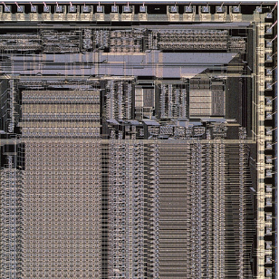
A picture of ARM1 processors, from article “25 microchips that shook the world”

ARM3 has minor improvements. It improves the bandwidth, clock frequency, flash and RAM.μ-SD technology, used for storing reduced format represents a large quantity of data is used in this generation of chips. Chips in these cores are usually used to develop portable device such as applications for wearable devices. Also, another important aspect of this generation of chips is that bus technology starts to be used in this generation of ARM chips, giving the possibilities that the devices can be run as a standalone. [5]
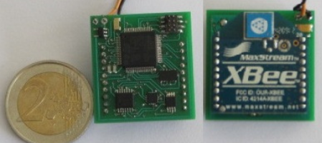
Pic: ARM3 Chips, low power consumption, higher performance abilities, usually for wearable devices.

ARM6 continues to improve the performance of ARM chips and reduce power consumption. This generation of chips improved video and picture processing abilities, data transfer abilities and it enlarges its instruction sets. DRAM technology first appears in ARM’s chips. More load and store based instructions have been added up into this generation of chips. [6]
The glinting part of ARM7 is that it improves multimedia ability of the chips. The cost of this generation of chips also drops dramatically. So, many computer vendors cut their prices down after the release of this generation of chips. [7] Due to its high performance, scientists even start to use it in crystallography area where high differentiate rates of a picture is required. Technologies such as SRAM and FLASHROM are used in this generation of chips, contributing to the speed up of this generation of chips. One more important thing is that C library is provided in this generation of chips.[8]
ARM8 kernel uses 13 level integer instruction line and 10 NEON command line and improves the instruction branch prediction. It use symmetrical double ALU superscalar pipelining, supports launching two parallel instructions and integrates level 2 cache. ARM8 uses TrustZone technology to ensure the safety of consumer products trading, data privacy and protected DRM.
Starts from ARM9, the structure of ARM chips changes from “Princeton structure” to “Harvard structure”, providing the potential possibility to increase the speed. By supporting Linux systems, it also gains the ability to perform as the “host chip”. Thus complex and challenging tasks such as QT-4 can be implemented on this generation of chips. [9]
ARM company define 6 kinds of instruction sets from v1 to v6. The prototype machine of ARMv1 is ARM1. But it was applied to business products. ARMv2 extended ARMv1, including supporting 32 bits multiplying order and co-processing order. ARMv3 is the first micro-processor that is a integrated CPU with on-chip cache, MMU and writing buffer.
On the aspects of instructions, the publish of ARMv4 instructions is a revolution. This revolution, to some researcher’s perspective, place even more essential than the later appearance of ARMv6 instructions, because it has instructions to support exception handling and context switches. [3] ARMv4 instruction sets have been improved so it can support 4 threads for hardware. By using PRET (a timing block strategy), this generation of chips are able to allocate resources according to certain situation using certain algorithms properly. [10]
ARMv5 instruction sets are been wildly adopted for embedded systems. It is especially good when performing emulation tasks. It can runs 7.4 times as fast as the common para-virtual strategy to deal with emulations. [11]
Important changes do not happen until year 2001, when the ARM cooperation introduced their ARMv6 ISA. ARM chip designers decide to improve the data parallelism and the thread parallelism abilities of the AMR processors. It is because of this reason that people are fortunately to see the birth of various technologies such as DSP, SIMD and SAD. This version of instruction sets are finally able to be implemented later in ARM11 chips. [3]

study design

This research will begin by briefly introduce the development of various versions of ARM instruction sets and ARM chips that implements them. Due to the limitation of time, abilities of the researcher and the possible law issues of copyright, the research will not go into details of each ARM chip and their instruction sets, it just provides a big picture.
Then the research will try to collect data representing the computability of each generation of ARM chips, analyze changes of computability and draw a relationship between the development of instructions and the development of the performance of the chips.
To go to an end, the research will analyze the importance of instruction sets in the develop procedures of the chips, following with the conclusion how an instruction set influence the performances of the chips.

data collection

The bandwidth of this generation of the processor has been improved to 5 MHz, flash to 512 KB and RAM to 64 KB. The power consumption was already reduced to a very low level. [5]
The power consumption of ARM6 is only 54mWarts / 3 volts, however, it has a clock frequency at 20MHz. Cache has been improved to 4 kB. The video controller can be connected to an 800 * 600 screen to show the contents of displays. The I/O data bus can be extended to 16-bits. It has 31 general purpose registers, each 32 bits wide. [6]
ARM7 structure speeds up the multi-media section by average 3.41 times as before.AES symmetric block is implemented in this generation of chips so that it can achieve the 128 bit I/O input and output. RAM of this generation in the chips are been enlarged to 256 KB. Also, clock has been speed up to 100 MHz. [7]
ARM8 speed up from 600MHz to 1GHz. And ARM8 can satisfy the power optimization requirement of the mobile equipment below 300mW. All in all, ARM8 is a high performance processor and it provides a reliable high performance solution.
ARM9 processor is aimed at making most advanced, high efficient, dynamic variable length, multi-issue, superscalar framework. ARM9 uses out-of-order execution 8 stage pipe processor. So it can provide high performance and high energy efficiency to the products.
The performance of the ARM11 chip is dramatic. Below is a snapshot showing the improvement of ARM11 chips from paper Parallelism and the ARM instruction set architecture:

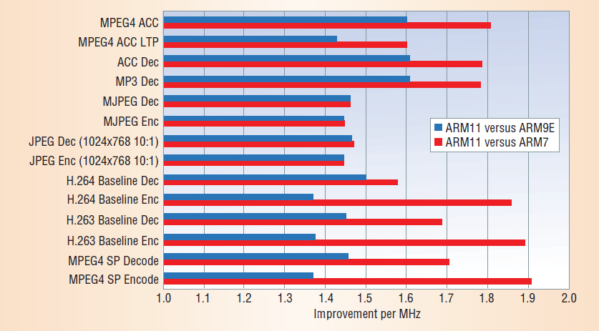

data analysis

A general tendency that can be viewed from the literature review and data collected is that ARM processors are performing better and better generation by generation. More and more technologies are being used in the development of the processors. The multi-media processing tasks, such as image processing and video processing, are become more and more efficient and clear through the develop procedures of the chips. Lower energy consumption, lower cost does not harm the performance of the chips. Instead, quicker memory and I/O accesses, quicker clock frequencies and stronger data processing abilities have been viewed with time going by.
It is worth noticing that the chips have been developed from a single core with a single thread to multi-core chips that supports multi-threading programs. It is also worth noticing that instruction sets also have been enlarged and enriched during the development procedure of the chips, providing better instructions for data loading, data storing and data manipulating.
The important point is that it can be concluded from the data, a stronger tendency may be building between the development of ARM chips and the development of ARM instruction sets.

VI.RECOMMENDATION

As shown previously, the tendency of the development of ARM chips and the development of ARM instruction sets seems becoming more and more inter-crossing. This is a good and important tendency to notice because under the background of the slowing down of Moore’s law, this tendency probably provides a totally new perspective that we view chips. [12] Instead of focusing on the chip itself, the size, the power consume, for example, it may be a better way to focus on the instruction sets instead. This may be a strategy: Chip vendors develop their instruction sets first, and then see what is the current distance between the real implementation of the instruction sets and the chips now. Based on this information, they can modify their chips to make the chips suitable for implementing the newest instruction sets. And then they modify instruction sets, and then chips again. So it becomes a circle that both instruction sets and chips keep going revolution, providing the possibility to get down the risk of the slow down of Moore’s law.

VII.PROBLEM AND LIMITATION

- Due to the limit of time and the ability of the researcher this research may be bias.
- The research points out the relationship between the development of instruction sets and the development of chips. However, further and detailed researches are needed about how the cycle of “instruction sets enlarge -chip development” can be maintain because no such a model in history shows the idea really works.
- This research does not point out a detailed idea of how to develop instruction sets based on the recent theories and technology, this part is also a good topic in the near future when Moore’s law really starts to “die out”.

IX. CONCLUSION

As is mentioned, the development of the cores are always seems to be “later” than the development of instruction sets and seems to be viewed as a less essential point by people. The development of cores give engineers chances to implement their instruction sets designed before. However, the development of instruction sets give the possibility of the development of instruction sets. It maybe seen from the this research and their relationship that both the development of two things have an acceleration on the development of another thing. Thus the research points out that “instruction set develop - chips develop” cycle maybe a good choice on dealing with the risks caused by the terminal of “Moore’s law” times.

X. References

- Wang GuanJun; Ye Feng; Zhang Ning; Wang Maoli, "Design and implementation of medical service robot with single arm and tracking function," Information and Automation (ICIA), 2013 IEEE International Conference on , vol., no., pp.840,843, 26-28 Aug. 2013
- Mark Hachman,"ARM Cores Climb Into 3G Territory", in Extreme technology,2002.
- Goodacre, J.; Sloss, A.N., "Parallelism and the ARM instruction set architecture," Computer , vol.38, no.7, pp.42,50, July 2005
- Santo, B., "25 microchips that shook the world," Spectrum, IEEE , vol.46, no.5, pp.34,43, May 2009 doi: 10.1109/MSPEC.2009.4907384
- Noury, N.; Perriot, B.; Collet, J.; Grenier, E.; Cerny, M.; Massot, B.; McAdams, E., "ActimedARM - Design of a wearable system to monitor daily actimetry," Engineering in Medicine and Biology Society (EMBC), 2013 35th Annual International Conference of the IEEE , vol., no., pp.1851,1854, 3-7 July 2013 doi: 10.1109/EMBC.2013.6609884
- Muller, M., "ARM6: a high performance low power consumption macrocell," Compcon Spring '93, Digest of Papers. , vol., no., pp.80,87, 22-26 Feb. 1993 doi: 10.1109/CMPCON.1993.289641
- Ing-Jer Huang; Wen-Kai Huang; Rui-Ting Gu; Chung-Fu Kao, "A cost
effective multimedia extension to ARM7 microprocessors," Circuits and
Systems, 2002. ISCAS 2002. IEEE International Symposium on , vol.2, no.,
pp.II-304,II-307 vol.2, 2002 doi: 10.1109/ISCAS.2002.1010985
[8] Drutarovsky, M.; Varchola, M., "Cryptographic System on a Chip based on Actel ARM7 Soft-Core with Embedded True Random Number Generator," Design and Diagnostics of Electronic Circuits and Systems, 2008. DDECS 2008. 11th IEEE Workshop on , vol., no., pp.1,6, 16-18 April 2008
doi: 10.1109/DDECS.2008.4538778
[9] Feng Ran; Tao Wang; Sijie Ran, "Implementation of the Qt4 test bench based on Arm9," Electrical & Electronics Engineering (EEESYM), 2012 IEEE Symposium on , vol., no., pp.198,201, 24-27 June 2012
doi: 10.1109/EEESym.2012.6258623
[10] Prakash, A.; Patel, H.D., "An Instruction Scratchpad Memory Allocation for the Precision Timed Architecture," Computer-Aided Design of Integrated Circuits and Systems, IEEE Transactions on , vol.32, no.11, pp.1819,1823, Nov. 2013 doi: 10.1109/TCAD.2013.2269768
[11] Yuan-Cheng Lee; Chih-Wen Hsueh; Rong-Guey Chang, "Inline Emulation for Paravirtualization Environment on Embedded Systems," Embedded and Real-Time Computing Systems and Applications (RTCSA), 2011 IEEE 17th International Conference on , vol.1, no., pp.388,392, 28-31 Aug. 2011 doi: 10.1109/RTCSA.2011.50
[12] Rupp, K.; Selberherr, S., "The Economic Limit to Moore's Law," Semiconductor Manufacturing, IEEE Transactions on , vol.24, no.1, pp.1,4, Feb. 2011 doi: 10.1109/TSM.2010.2089811

